CTM-I Use Case

Dynamic Parm Add

Version 0.1

Use Case Name | Dynamic Parm Add
Actor | App Support
Pre-conditions /Assumptions | User has selected a specific Parm Definition to create a new parm for.
Post Conditions | User can choose to return to the previous browse screen by selecting the “Return to Browse” link. The link will take the user back to the browse screen they came from. The user’s latest search criteria and sorting will be used to display search results.
Screenshot | 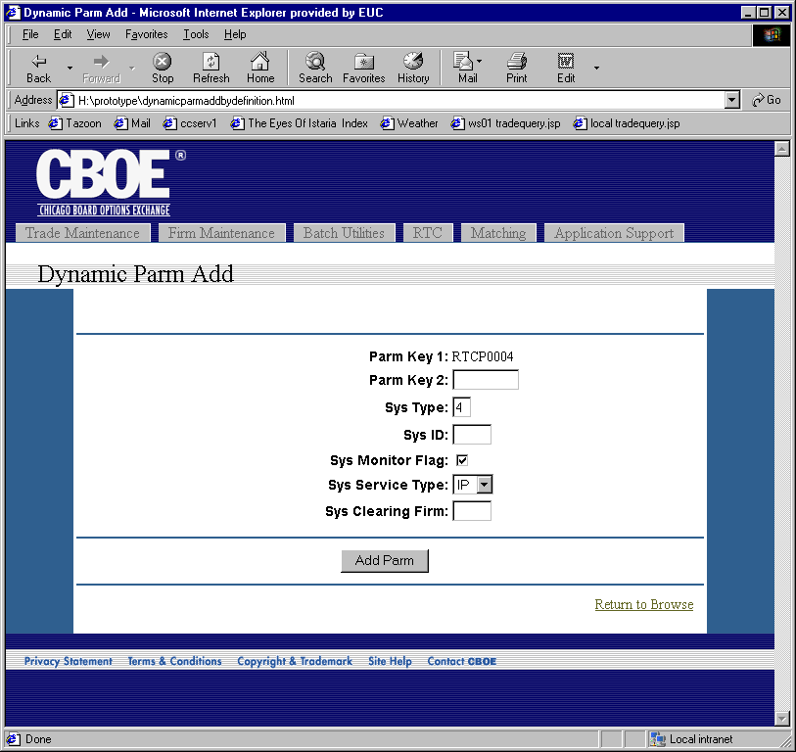
Flow of Events | - The proper Parm Definition is retrieved  - Generic Parm Add screen displays.  - Parm Key 1 and Parm Key 2 are read-only fields, if they are specific values in the Parm Definition and not wildcards. Key fields with a wildcard in the Parm Definition will be editable.  - The Parm Definition will determine editable fields. The Parm Definition type will be used to determine the type of input field and what validation to perform.  - Pressing the “Add Parm” button will request the parm to be added.  - The parm will be reformatted to the proper form based on the Parm Definition.  - The parm will be passed to CTM-R to save.  - Results from CTM-R will be displayed.
Alternative Path

